**Bug Reports**

1. Web UI

|  |  |  |  |  |
| --- | --- | --- | --- | --- |
| **Testing** | **Total** | **Passed** | **Failed** | **Pending** |
| ***Create Testing***  ***User***   1. Authentication 2. Dashboard 3. Course 4. Profil   ***Admin***   1. Dashboard | 67  13  4  24  13  20  20 | - | - | - |
| ***Manual Testing***  ***User***   1. Authentication 2. Dashboard 3. Course 4. Profil   ***Admin***   1. Dashboard | 67  47  13  4  21  9  20  20 | 67  41  7  4  21  9  15  15 | 6  6  6  0  0  0  0  0 | 0  0  0  0  0  0  0  0 |
| ***Automation Testing***  ***User***   1. Authentication 2. Dashboard 3. Course 4. Profil   ***Admin***   1. Dashboard | 59  39  7  4  18  9  20  20 | 59  39  7  4  18  9  20  20 | 0  0  0  0  0  0  0  0 | 0  0  0  0  0  0  0  0 |

* Manual Testing

Url record manual testing : <https://www.awesomescreenshot.com/s/folder/F052DVdv19/d6e8a8d02749da61312ee3375139cde6>

Bug Report :

|  |  |  |  |
| --- | --- | --- | --- |
| Feature | Bug | Proof | Revisi |
| Forget Password | Not yet validation |  | - |

* Automation Testing

Bug Report :

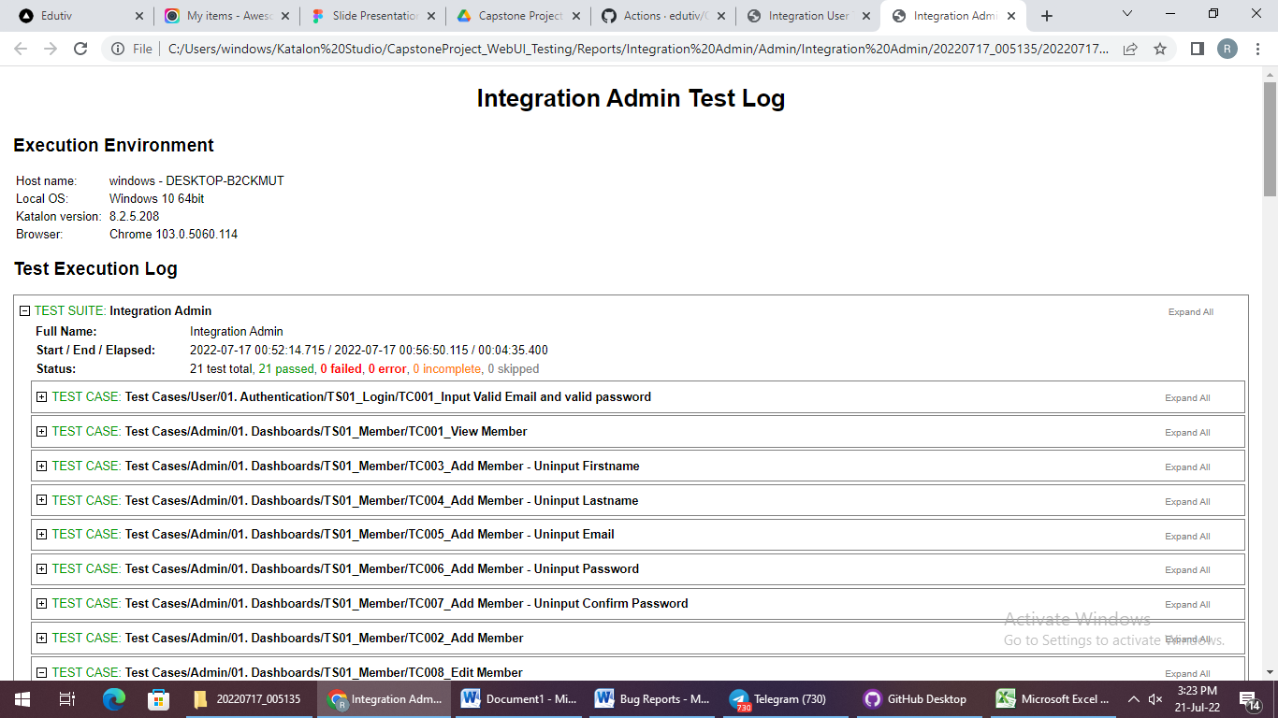

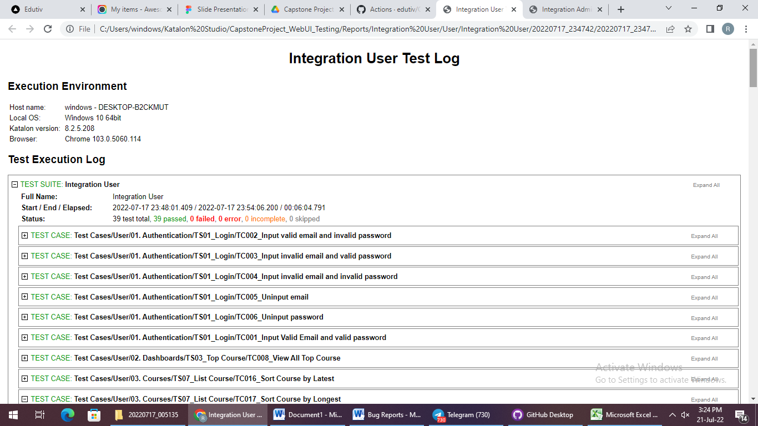

1. Rest API Testing

|  |  |  |  |  |
| --- | --- | --- | --- | --- |
| **Testing** | **Total** | **Passed** | **Failed** | **Pending** |
| ***Create Testing***   1. Category 2. User 3. Course 4. Section 5. Material 6. Review 7. Tool 8. Enrolled Course | **78**  10  10  10  10  10  10  10  8 | - | - | - |
| ***Manual Testing***   1. Category 2. User 3. Course 4. Section 5. Material 6. Review 7. Tool 8. Enrolled Course | **78**  10  10  10  10  10  10  10  8 | **78**  10  10  10  10  10  10  10  8 | -  -  -  -  -  -  -  -  - | -  -  -  -  -  -  -  -  - |
| ***Automation Testing***   1. Category 2. User 3. Course 4. Section 5. Material 6. Review 7. Tool 8. Enrolled Course | **78**  10  10  10  10  10  10  10  8 | **78**  10  10  10  10  10  10  10  8 | -  -  -  -  -  -  -  -  - | -  -  -  -  -  -  -  -  - |

* Manual Testing

Url record manual testing : <https://www.awesomescreenshot.com/s/folder/F0L81EGWW8/809216d64131360df68cf05bc20be60d>

Bug Report :

|  |  |  |  |
| --- | --- | --- | --- |
| Feature | Bug | Proof | Revisi |
| Material | Pada bagian PUT Material response yang dihasilkan saat menginput id yang salah 200 (success) |  | Done |
| Saat send request PUT data bertambah (menjadi fungsi POST) |  | Done |

* Automation Testing

Bug Report :

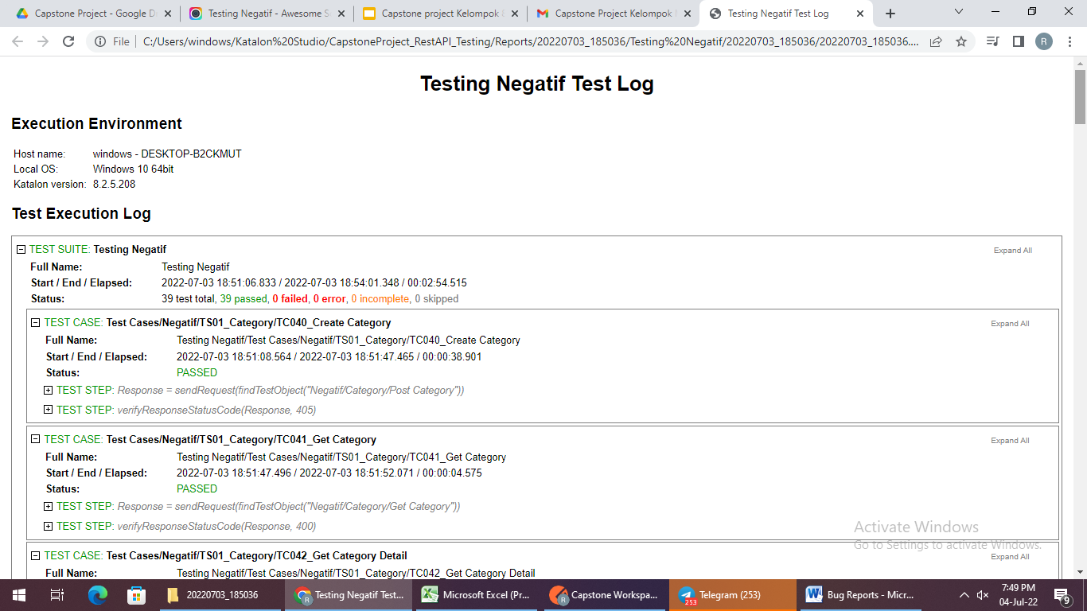

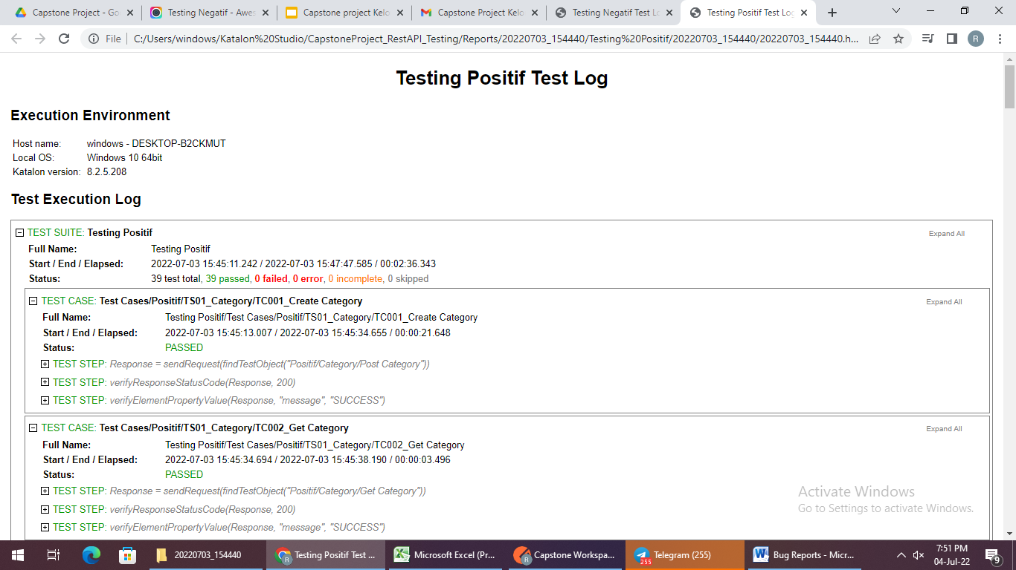

1. Mobile APP Testing

|  |  |  |  |  |
| --- | --- | --- | --- | --- |
| **Testing** | **Total** | **Passed** | **Failed** | **Pending** |
| ***Create Testing***   1. Authentication 2. Dashboard 3. Course 4. Profil 5. Wishlist | 50  13  1  21  13  2 | - | - | - |
| ***Manual Testing***   1. Authentication 2. Dashboard 3. Course 4. Profil 5. Wishlist | 50  13  1  21  13  2 | 44  7  1  13  12 | 6  6  0  0  0 | 0  0  0  0  0 |
| ***Automation Testing***   1. Authentication 2. Dashboard 3. Course 4. Profil 5. Wishlist | 40  7  1  17  13  2 | 38  7  1  15  13  2 | 2  0  0  2  0  0 | 0  0  0  0  0  0 |

* Manual Testing

Url record manual testing : <https://drive.google.com/drive/folders/1PjKluH8bWfqnrIS0JGggBlTBcCe58MVj?usp=sharing>

Bug Report :

|  |  |  |  |
| --- | --- | --- | --- |
| Feature | Bug | Proof | Revisi |
| Forget Password | Not yet validation |  | - |

* Automation Testing

Bug Report :

